**Controlling 2 Servo With Joystick On Arduino**

**Introduction**

When the joystick is moved in the horizontal direction, the first servo will move towards right or left and upon moving the joystick in the vertical direction, the second servo will move towards the right or left.

When the joystick module moves in the horizontal or in the vertical direction, it gives us values from 0 to 1023. So we can apply a condition in the code that if the value is less than 300 or greater than 700, then the servos will move.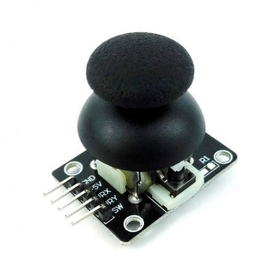

The Joystick module is **similar to analog joysticks found in gamepads**. It is made by mounting two potentiometers at a 90 degrees angle. The potentiometers are connected to a short stick centered by springs. This module produces an output of around 2.5V from X and Y when it is in resting. position.

**Components**

* Arduino UNO
* 2 Servo Motors
* Joystick Module
* Jumper Wires

**Application**

* Controlling DC Motors and Servo Motors
* Controlling LEDs
* Remote controlled Cars
* Robotic Control

**Objective**

During this activity ,you will help students to achieve following objectives

1. Understanding the principle and operation of servo motor control using joystick
2. Design algorithm and flowchart to servo motor control using joystick with Arduino
3. Programming servo motor control by joystick using Arduino uno
4. Interfacing servo motor control by joystick using Arduino uno

**Programming steps**

1.Initialise variables for two servo motors

2.initialise pin of joystick module and signal pin of servo motor

3.Declare vertical and horizontal pin pin on joy stick as input

## 4.read status of horizontal and vertical position input

5. check if value of horizontal position is less than(<300),first servo motor will move right

6. if value of horizontal position is greater than(>700),first servo motor will move left.

7.if value of vertical position is less than(<300),second servo motor will move left.

8.if value of vertical position is greater than(>700),second servo motor will move right

**Programming**

#include<Servo.h>

Servo servo1;

Servo servo2;

int x_key = A1;

int y_key = A0;

int x_pos;

int y_pos;

int servo1_pin = 8;

int servo2_pin = 9;

int initial_position = 90;

int initial_position1 = 90;

void setup ( ) {

Serial.begin (9600) ;

servo1.attach (servo1_pin ) ;

servo2.attach (servo2_pin ) ;

servo1.write (initial_position);

servo2.write (initial_position1);

pinMode (x_key, INPUT) ;

pinMode (y_key, INPUT) ;

}

void loop ( ) {

x_pos = analogRead (x_key) ;

y_pos = analogRead (y_key) ;

if (x_pos < 300){

if (initial_position < 10) { } else{ initial_position = initial_position - 20; servo1.write ( initial_position ) ; delay (100) ; } } if (x_pos > 700){

if (initial_position > 180)

{

}

else{

initial_position = initial_position + 20;

servo1.write ( initial_position ) ;

delay (100) ;

}

}

if (y_pos < 300){

if (initial_position1 < 10) { } else{ initial_position1 = initial_position1 - 20; servo2.write ( initial_position1 ) ; delay (100) ; } } if (y_pos > 700){

if (initial_position1 > 180)

{

}

else{

initial_position1 = initial_position1 + 20;

servo2.write (initial_position1 ) ;

delay (100) ;

}

}

}

**Hardware**

**Instructions**

* Connect the VCC on the joystick module with the 5V pin on the Arduino
* Connect the GND pin on the joystick module with the GND on the Arduino
* Connect the VER pin on the joystick module with the A0 on the Arduino
* Connect the HOR pin on the joystick module with the A1 on the Arduino

After that, connect the servo motors with the Arduino. The connections for servo motors with Arduino are as follows:

* Connect the black wire on both the servo motors with the GND on the Arduino
* Connect the red wire on both the servo motors with the 5V pin on the Arduino
* Connect the yellow wire on the first motor with pin 8 on the Arduino
* Connect the yellow wire on the second motor with pin 9 on the Arduino

